**8. Write the PHP programs to do the following:**

**a. Implement simple calculator operations.**

Program:

<!DOCTYPE html>

<html lang="en">

<head>

<meta charset="UTF-8">

<meta http-equiv="X-UA-Compatible" content="IE=edge">

<meta name="viewport" content="width=device-width, initial-scale=1.0">

<title>Document</title>

</head>

<body>

<form action="lab8a.php" method="post">

<p id="p1">Opernad 1: <input type="number" id="t1" name="t1"></p>

<p id="p2">Opernad 2: <input type="number" id="t2" name="t2"></p>

<input type="submit" id="b1" name="add" value="ADD">

<input type="submit" id="b2" name="sub" value="SUB">

<input type="submit" id="b3" name="mul" value="MUL">

<input type="submit" id="b4" name="div" value="DIV">

<p id="res">Result :

<?php

$res=0;

if(isset($_POST['add']))

{

$num1 = $_POST['t1'];

$num2 = $_POST['t2'];

$res = $num1 + $num2;

}

if(isset($_POST['sub']))

{

$num1 = $_POST['t1'];

$num2 = $_POST['t2'];

$res = $num1 - $num2;

}

if(isset($_POST['mul']))

{

$num1 = $_POST['t1'];

$num2 = $_POST['t2'];

$res = $num1 * $num2;

}

if(isset($_POST['div']))

{

$num1 = $_POST['t1'];

$num2 = $_POST['t2'];

$res = $num1 / $num2;

}

echo $res;

?>

</p>

</form>

</body>

</html>

**Output:**

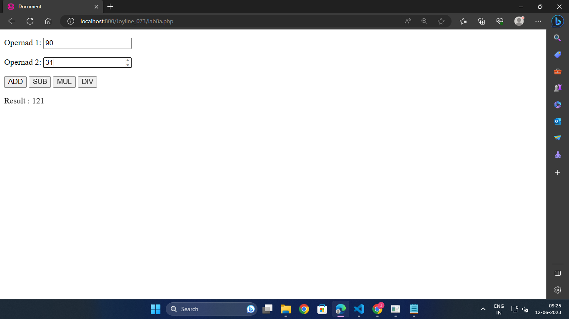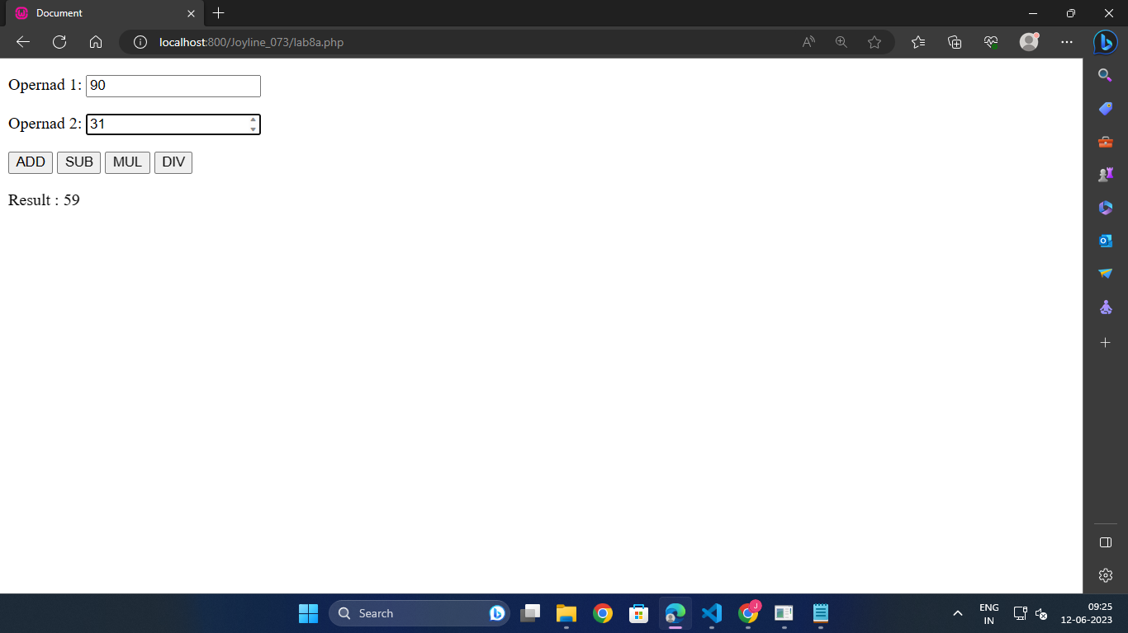

**b. Find the transpose of a matrix.**

Program:

<!DOCTYPE html>

<html lang="en">

<head>

<meta charset="UTF-8">

<meta http-equiv="X-UA-Compatible" content="IE=edge">

<meta name="viewport" content="width=device-width, initial-scale=1.0">

<title>Document</title>

<style>

h3{

text-align: center;

}

.matrix{

margin-left: 150px;

margin-top: 50px;

}

</style>

</head>

<body>

<h3>Web Lab 8b</h3>

<div class="matrix">

<?php

$mat=Array( Array(6,1),

Array(5,7),

Array(2,0) );

$transpose = Array();

echo "<html><head><title>Matrix Transpose</title></head><body>";

echo "<p>Matrix is:<br/>";

for($i = 0; $i < count($mat); $i++)

{

for ($j = 0; $j < count($mat[0]); $j++)

{

echo $mat[$i][$j] . " ";

}

echo "</br/>";

}

echo "</p>";

for($i = 0; $i < count($mat); $i++) //calculation for Transpose

for($j = 0; $j < count($mat[0]); $j++)

{

$transpose[$j][$i]=$mat[$i][$j];

}

echo "<p>Transpose of a Matrix is:<br/>";

for($i = 0; $i < count($transpose); $i++)

{

for ($j = 0; $j < count($transpose[0]); $j++)

{

echo $transpose[$i][$j] . " ";

}

echo "<br/>";

}

echo "</p>";

echo "</body> </html>";

?>

</div>

</body>

</html>

**Output:**

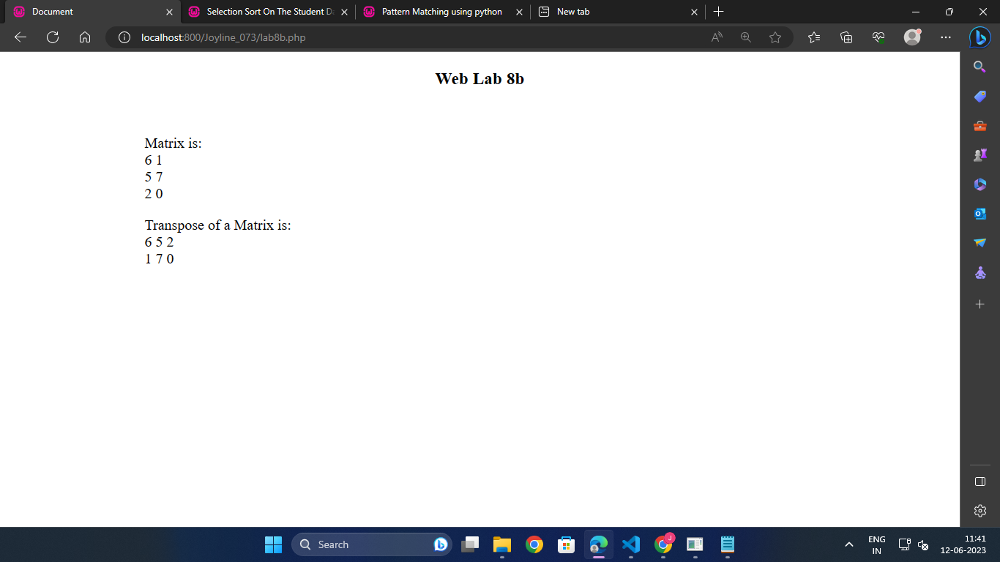

**c. Multiplication of two matrices.**

Program:

<!DOCTYPE html>

<html lang="en">

<head>

<meta charset="UTF-8">

<meta http-equiv="X-UA-Compatible" content="IE=edge">

<meta name="viewport" content="width=device-width, initial-scale=1.0">

<title>Document</title>

<style>

h3{

text-align: center;

}

p{

margin-left: 30px;

}

</style>

</head>

<body>

<h3>Web Lab 8c</h3>

<h5>Matrix Multiplication:</h5>

<?php

$mat1=Array(Array(6,1),

Array(5,7),

Array(2,0));

$mat2=Array(Array(4,4,8),

Array(2,0,5));

echo "<html><head><title>Matrix Multiplication</title></head><body>";

if(count($mat1[0])!=count($mat2))

{

echo "<p>Incompatible Matrices</p>";

exit(0);

}

$res=array();

echo "<p>Matrix A:<br/>";

for($i = 0; $i < count($mat1); $i++)

{

for ($j = 0; $j < count($mat1[0]); $j++)

{

echo $mat1[$i][$j] . " ";

}

echo "<br/>";

}

echo "</p>";

echo "<p>Matrix B:<br/>";

for($i = 0; $i < count($mat2); $i++)

{

for ($j = 0; $j < count($mat2[0]); $j++)

{

echo $mat2[$i][$j] . " ";

}

echo "<br/>";

}

echo "</p>";

for($i = 0; $i < count($mat1); $i++)

for($j = 0; $j < count($mat2[0]); $j++)

{

$res[$i][$j]=0;

for($k=0;$k<count($mat2);$k++)

$res[$i][$j]=$res[$i][$j]+$mat1[$i][$k]*$mat2[$k][$j];

}

echo "<p>A x B:<br/><br>";

for($i = 0; $i < count($res); $i++)

{

for ($j = 0; $j < count($res); $j++)

{

echo $res[$i][$j] . " ";

}

echo "<br/>";

}

echo "</p>";

echo "</body></html>";

?>

</body>

</html>

**Output:**

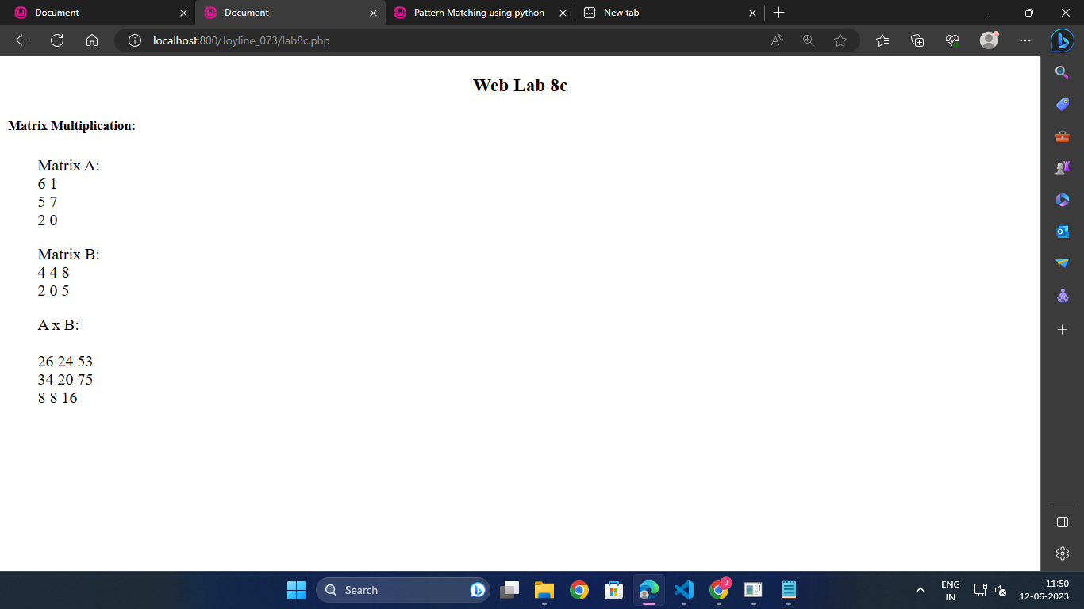

**d. Addition of two matrices.**

Program:

<!DOCTYPE html>

<html lang="en">

<head>

<meta charset="UTF-8">

<meta http-equiv="X-UA-Compatible" content="IE=edge">

<meta name="viewport" content="width=device-width, initial-scale=1.0">

<title>Document</title>

<style>

h3{

text-align: center;

}

p{

margin-left: 30px;

}

</style>

</head>

<body>

<h3>Web Lab 8d</h3>

<h5>Matrix Addition:</h5>

<?php

$mat1 = Array(Array(3,8),

Array(1,5),

Array(4,0));

$mat2=Array(Array(6,1),

Array(4,2),

Array(3,3));

echo "<html><head><title>Matrix Addition</title></head><body>";

if((count($mat1)!=count($mat2))||(count($mat1[0])!=count($mat2[0])))

{

echo "<p>Incompatible Matrices</p>";

exit(0);

}

echo "<p>Matrix A:<br/>";

for($i=0;$i<count($mat1);$i++)

{

for ($j = 0; $j < count($mat1[0]); $j++)

{

echo $mat1[$i][$j] . " ";

}

echo "<br/>";

}

echo "</p>";

echo "<p>Matrix B:<br/>";

for($i = 0; $i < count($mat2); $i++)

{

for ($j = 0; $j < count($mat2[0]); $j++)

{

echo $mat2[$i][$j] . " ";

}

echo "<br/>";

}

echo "</p>";

$res=array();

for($i = 0; $i < count($mat1); $i++)

for($j = 0; $j < count($mat1[0]); $j++)

{

$res[$i][$j]=$mat1[$i][$j]+$mat2[$i][$j];

}

echo "<p>A + B :<br/>";

for($i = 0; $i < count($res); $i++)

{

for ($j = 0; $j < count($res[0]); $j++)

{

echo $res[$i][$j] . " ";

}

echo "<br/>";

}

echo "</p>";

?>

</body>

</html>

**Output:**

